News Release for VFD Pro Subscribers to Send to Clients
News Release
Suggested image, (please note that you will need to pay for the license, this is from Adobe, see the link below).
https://stock.adobe.com/uk/images/paid-vs-free-choice-concept/175517243?prev_url=detail
Reporting Your Key Performance Indicators Every Month – Now a Standard Part of the Service
As part of ‘Name of Companies’ determination to help you and your business be more successful, from December 2020 we will be offering all of our clients (on Sage and Xero) the invaluable Business Overview Report as a standard part of our service.
The Business Overview Report is a deceptively detailed suite of management information packed into a concise 2 page report.
Page one records your financial performance over the last two years and compares the most recent month, quarter and year with the corresponding period 12 months before showing you exactly how your sales, cost of sales, overheads and profit has moved.
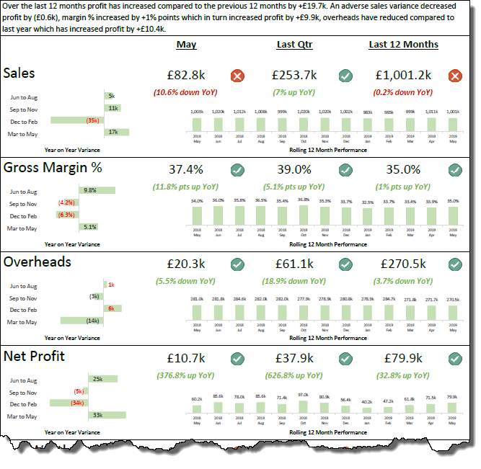
As we can see the business illustrated here has contracted slightly in sales, however the Net Profit year on year shows a healthy 32.8% increase, so one could be forgiven for thinking all was well.
As your business is potentially your most valuable asset, we also remind you of the Net Worth of your business as each month goes by. (Net Worth = Total Assets – Total Liabilities). In the example below we can see that whilst the profit has increased, the Net Worth has decreased by £11,000, why?
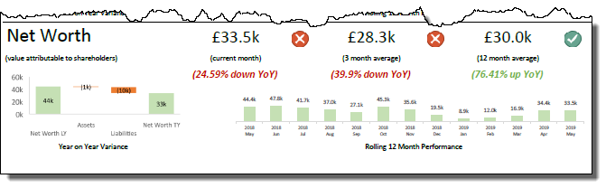
Your revenue, costs, profitability and net worth are however historic data. These are your Lag Indicators because they have already happened. Yes, the information is bang up to date, (so long as your bookkeeping is accurate and up to date), but they are already consigned to history.
The real value lies on page 2 where you will see the ‘Lead Indicators’ for your business laid out in black and white, (or red and green, where red is a negative variance, and green is a positive variance).
Sales is a function of the Total Number of Transactions multiplied by the Average Value per Transaction. These two Key Performance Indicators (KPI’s), are extremely important, and yet very few people know and understand them, let alone record and track progress as they strive to make improvements.
As a ‘Name of Company’ client we record these two essential KPI’s and provide them to you every month so you can track progress month by month with not only the absolute number, but also the impact on your revenue.
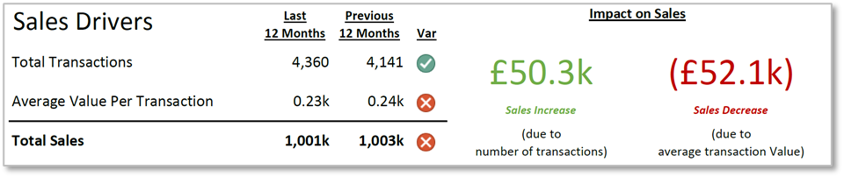
Your customers are your greatest asset so it is imperative that you know what is happening to your rate of New Customer Acquisition and your rate of Customer Retention. Your Business Overview Report will highlight the movement in both of these KPIs and provide an indication of their impact on sales every month.
In this example we have a very worrying trend with both the rate of New Customer Acquisition and Retention pointing to tough times ahead unless the trend can be reversed. As the Business Overview Report is updated every month, you can now track your progress to reassure yourself that you are moving in the right direction.
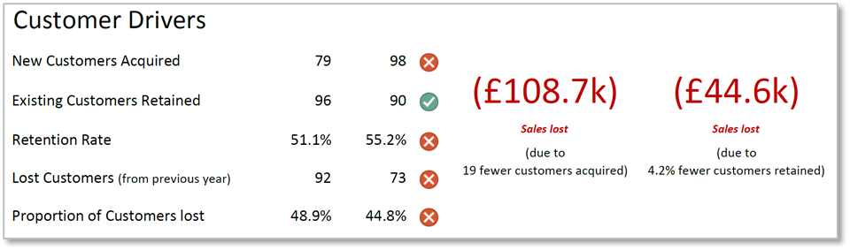
How about the trend with regards profitable versus loss making months? With the Business Overview Report, we let you know how you are performing on that metric month by month too:
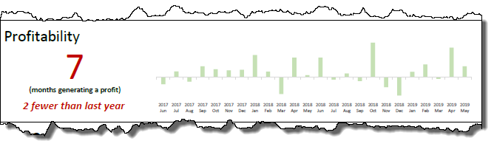
How about your liquidity and your performance with regards getting your customers to pay you on time. The current ratio, (The current ratio is a liquidity ratio that measures whether a firm has enough resources to meet its short-term obligations).
Unless you are running a cash business, it is helpful to know exactly how well you are doing with your debt collections and your payments to suppliers. These KPI’s and the movement year on year are detailed in your Business Overview Report, this business is taking on average 71.8 days to get paid, and it is getting worse:
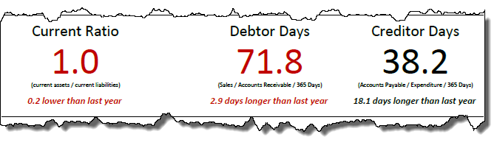
And finally the answer to the question, ‘how come my accounts say I am making a profit but what happened to the cash?’ the answer is provided in the waterfall chart below that shows the how the Cash has moved in the last 12 months.
